Screw Extruder Manual

# Introduction

The screw extruder for the project MEC8370-22 is functioning filament extruder with fully controllable parameters and an integrated filament winder. It uses a custom firmware available at the following link:

# Installation

The screw extruder needs to be installed in two modules, the screw extruder itself and the control box. The two sub-systems need to be installed and plugged together correctly before being used.

1. Install the screw extruder at the back of the work surface with the nozzle pointing right (wire will be towards the front of the desk)

Image of screw placement

1. Install the control box carefully in front with the LCD screen facing forward

Image of Box placement

1. Install the fan on the left to face the stepper driver (This fan is needed there to remove risks of overheat. Another fan can be plugged in parallel and placed near the filament to cool it down)

Image of fan placement

1. Place the filament winder motor vertically near the nozzle
2. Remove the top plastic module from the filament winder and place a spool
3. Replace the top cap with the good orientation

Image of filament placement and spool

1. Connect all the corresponding letters together (cable A on the screw extruder with cable A from the control box)

Image of cable connection

1. Connect the screw motor wires together (letter M). The colors of the four wires should match (blue with blue, green with green, etc.)

Image of motor cables

1. Place the thermocouples at the corresponding places:
   1. Thermocouple N should on the nozzle, on the top, under the metal tie wrap with the thermocouple wire directly in contact with the heater band (under the fastening connector)

Image of nozzle thermocouple and placement

* 1. Thermocouple P1 should be on the first preheat band starting from the nozzle, under the barrel, under the metal strap with the thermocouple wire directly in contact with the heater band (under the fastening connector)

Image of first preheat thermocouple and placement

* 1. Thermocouple P1 should be on the second preheat band starting from the nozzle, under the barrel, under the metal strap with the thermocouple wire directly in contact with the heater band (under the fastening connector)

Image of second preheat thermocouple and placement

1. Connect an IEC C14 cable (computer desktop cable) to the back connector.

Image of power connector

When this is done, the screw extruder should be ready to start.

# Start-up

Three different are available for start-up: normal start-up, manual PID start-up and automatic PID start-up.

To start in normal mode:

1. Keep PID switch in the center

Image of PID switch

1. Close the emergency switch

Image of emergency switch

1. Click the start switch downwards to start the control box

Image of start switch

1. The screw extruder should start directly with the saved information on the SD card as PID gains

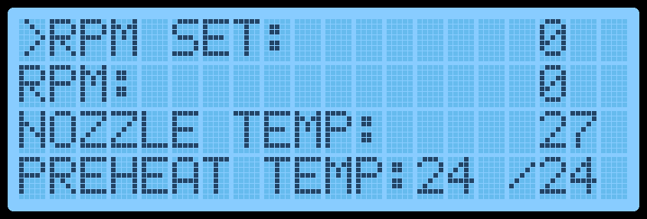

To start in manual PID mode:

1. Keep PID switch to the left most position

Image of PID switch

1. Close the emergency switch

Image of emergency switch

1. Click the start switch downwards to start the control box

Image of start switch

1. The screw extruder should start directly with the manual PID mode.

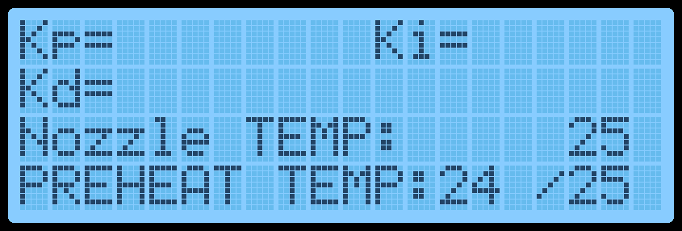

In manual PID mode, the three gains for the PID are entered directly by the user one ate the time (Careful: The screw extruder will heat up to 100°C during this mode). The encoder must be used to set parameters.

Image of encoder

1. Turn left to reduce the Kp gain
2. Turn right to increase the Kp gain
3. Click the encoder to set the gain
4. Repeat 1 to 3 for Kd and Ki
5. After setting Ki, the screw extruder should start to the main menu

To start in automatic PID mode:

1. Keep PID switch to the right most position

Image of PID switch

1. Close the emergency switch

Image of emergency switch

1. Click the start switch downwards to start the control box

Image of start switch

1. The screw extruder should start directly with the manual PID mode.

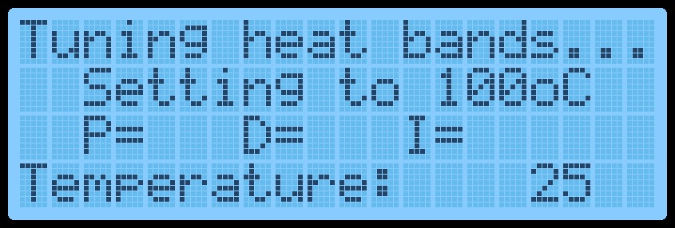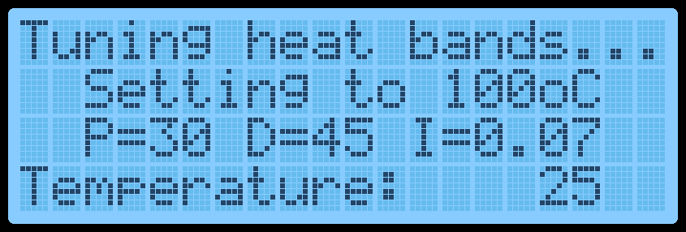

In automatic PID mode, the screw extruder will cycle through heating and cooling cycles around 100°C to calculate the PID gains, set them and save them in the device. At the end, it will show for one minute the PID gains calculated and then start in the main menu.

# Main operation

The screw extruder uses a one line menu with five different: Nozzle temperature, preheat temperature, fan speed, winder speed, rpm speed.

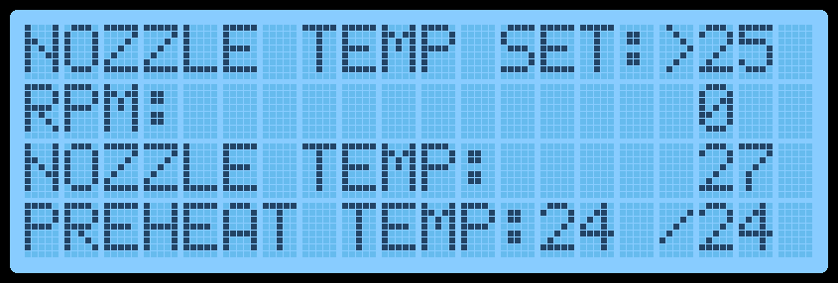

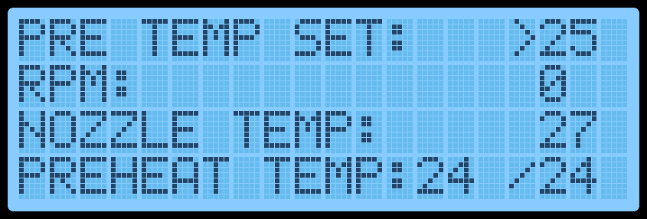

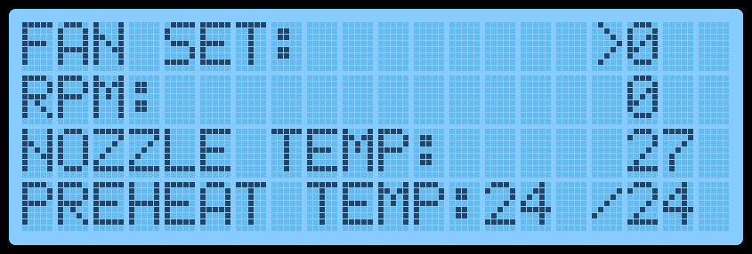

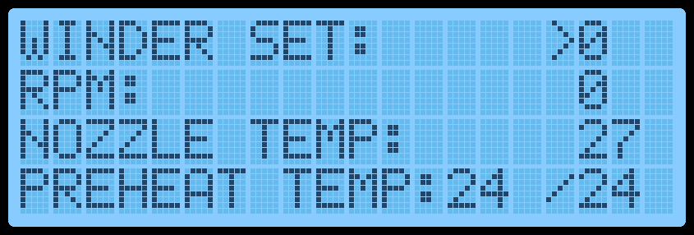

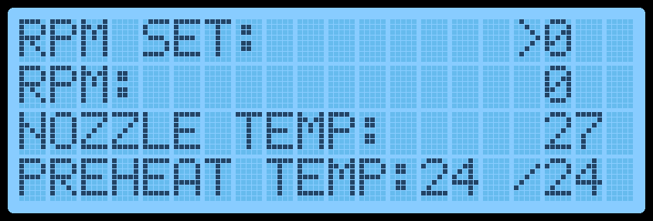

To operate the device only the encoder is needed:

1. Turn left to go to a previous menu
2. Turn right to go down the menu list
3. Click to enter a menu



In a sub-menu, the value can be entered via the encoder:

1. Turn left top decrease the number
2. Turn right to increase the number
3. Click to set the value and return to the menu selection



The nozzle temperature screen will set the nozzle temperature up to 425°C (The firmware blocks higher temperatures). CAUTION: Increasing the temperature should only be done by jumps of 100°C since the PID is tuned to this value. If the firmware and PID are updated, greater jumps are possible.

The preheat temperature screen will set the two preheat temperature up to 425°C (The firmware blocks higher temperatures). CAUTION: Increasing the temperature should only be done by jumps of 100°C since the PID is tuned to this value. If the firmware and PID are updated, greater jumps are possible.

The fan speed sets the fan speed in a level base from 0 (turned off) to 10 (max power). Setting a negative value will not do anything and setting a value greater than 10 will set the speed at a level 10.

The winder speed sets the speed for the filament winder stepper motor connected to the control box. The speed is in RPM. A negative speed will make the motor turn counter-clockwise and positive clockwise. The max speed is around 60.

The RPM menu sets the main speed for the screw in RPM. A negative speed will make the motor turn counter-clockwise and positive clockwise. The max speed is around 25.

The three lines under the menus represent the read values for the speeds and temperature of the device as visual feedback. The top is the read main motor speed read via the optical encoder. The nozzle temp represents the nozzle temperature. The preheat temp represents in order form left to right the P1 and P2 temperatures.

To operate:

1. Set the fan speed to 8 for the stepper driver

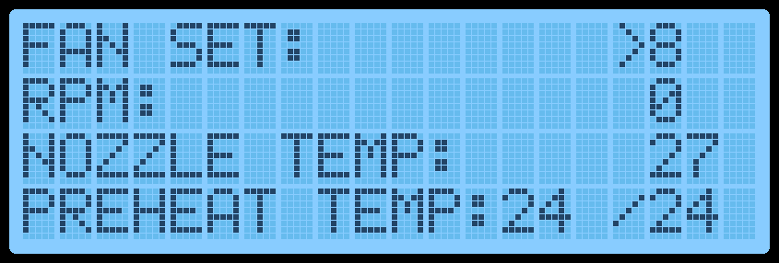

1. Set the nozzle temperature to 100°C and the preheat temperature to 100°C.
2. Wait for stabilisation (few seconds)

Image set nozzle temp and preheat temp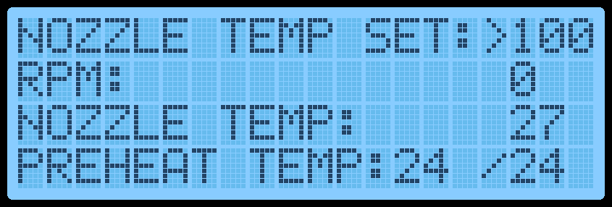

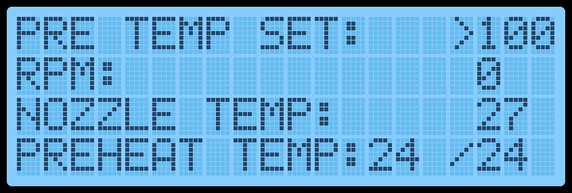

1. Set the nozzle temperature to 200°C and the preheat temperature to 200°C.
2. Wait for stabilisation (few seconds)
3. Repeat 1 to 4 until desired temperatures are met
4. Wait for the screw barrel to get a uniform temperature (nozzle to base). This can take up to an hour. To test when the temperatures are good enough:
   1. Insert a fine stick in the nozzle and feel if the plastic is melted enough

Image insert fine stick good vs bad

* 1. Place a plastic filament on the nozzle and check if the filament melts

Image plastic melting

* 1. Measure the nozzle temperature

Image measure temp

* 1. Check if plastic filament feeds out even when the motor is still

Image filament oozing

1. When the barrel is hot enough, set the motor speed (for example, the optimal speed for PEI is around 1 or 2 RPM).



1. Insert the polymer or mix in the funnel

Image funnel

1. Collect via a pair of tweezers or by spooling the filament to the desired speed depending on the output speed (for example, the optimal winder speed for PEI is around 5 to 10 RPM)

Image tweezer and spooling

# Purging material

The screw extruder can be purged via purging material to clean it while it runs. The use of purging material works exactly like the normal operations, but some measures must be taken in account when using it:

1. While pellets work as demonstrated with PLA, the screw extruder is not designed for it and more care should be put when using pellets (lower speed and higher temperatures)
2. For purging material, since viscosity is higher, higher torque is required giving the need for slower speeds for the motor
3. To high temperature can cause the purging material to melt prematurely and get stock near the funnel. It can be needed to remove the funnel and remove with tweezer the clog
4. Careful to not burn the material
5. Purging is a really long process so optimize your time with your polymer types (can take up to 2 or 3 hours to make sure no dusts or garbage is still present)

# Safety

If anything does not work the way intended (Temperature not increasing, motor stall, structure deformation, etc.), SWITCH THE EMERGENCY BUTTON ON to stop all power input to the power supply and ensure no power is delivered to the 12V DC electronics and the 120V AC electronics.

If temperature measurements are 20°C higher than the set temperature for this device, a loud 1 Hz buzzer will turn on and off intermittently.

If the temperature is higher than 430°C, the software will automatically shutdown and enter a safety mode that disables any heating power until all temperatures are under 50°C.

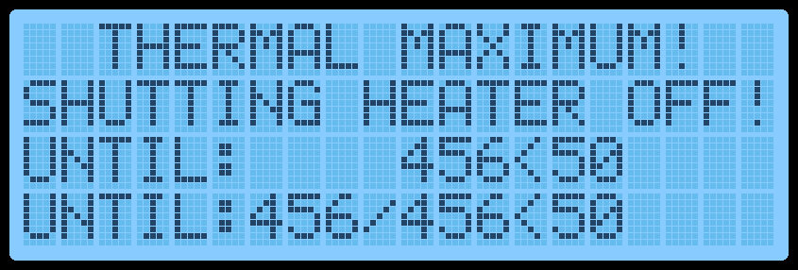

When a safety measure is triggered, please verify all circuitry and connections before turning back on.

# Polymer incorporation

To put the polymer, simply put the mix in the barrel and close the lid. Then, start the motor for the polymer to go up the barrel.

The polymer needs to be dried before used and mixing. The drying parameters used are as follow:

* PLA: 4h@70°C
* PEI: 4h@150°C

The PEI is influenced rapidly by moisture and needs to be continuously dried when using it.

# Turning off

When turning the device off:

Image de chaque étape

1. Turn motors to 0 RPM
2. Turn all heaters off (lower than ambient temperature)
3. Wait for temperature reading to go under 100°C (for safety)
4. Turn start switch off
5. Trigger the emergency button
6. Disconnect power cable
7. Disconnect all connections
8. Replace the sub-systems in their specified locations

# Disassembly and repair

No precaution is necessary when disassembly and repairing the screw extruder. Some standard things are mandatory as:

1. Make sure power is turned off and disconnected (with emergency button triggered)
2. Make sure that temperatures are low enough for handling
3. Do not keep high temperature material in proximity with low temperature components

It is easier to disassemble the motor bracket first before removing the barrel from it’s support. However, the other way around is also possible.

Disassembly is mostly done when emptying the nozzle by unscrewing it and removing excess polymer with tweezers or unscrewing the funnel plate to remove clogged polymer in the funnel chamber.

# Regolith precautions

When using regolith mixture material in the screw extruder, make sure to follow the safety guidelines for regolith handling (use of an extractor and an enclosure is mandatory).